Ex.no:2
Date:15/2/25
5. Write a java script to validate the fields of the registeration page.
Aim:
To write java script to validate the following fields of the registration page.
First name (Name contain alphabets and length Should not be less tham 6 characters).
Password(Password should not be less than characters).
E-mail id (should not contain any invalid and must follow satandard pattern name@domain.com)
Mobile should contain 10 digits
Last name should be empty.
Program:
FormValidate.html:
<!DOCTYPE html>
<html>
<head>
<title>Simple Registration Validation</title>
<script>
function validateForm() {
var firstName = document.getElementById("firstName").value;
var password = document.getElementById("password").value;
var email = document.getElementById("email").value;
var mobile = document.getElementById("mobile").value;
var lastName = document.getElementById("lastName").value;
var address = document.getElementById("address").value;

if (firstName.length < 6 || !/^[A-Za-z]+$/.test(firstName)) {
alert("First Name must be at least 6 characters and contain only letters.");
return false;
}
if (password.length < 6) {
alert("Password must be at least 6 characters.");
return false;
}
if (email.indexOf("@") === -1 || email.indexOf(".") === -1) {
alert("Please enter a valid Email ID.");
return false;
}
if (mobile.length !== 10 || !/^\d{10}$/.test(mobile)) {
alert("Mobile number must be exactly 10 digits.");
return false;
}

if (lastName === "") {
alert("Last Name cannot be empty.");
return false;
}

if (address === "") {
alert("Address cannot be empty.");
return false;
}

alert("Form submitted successfully!");

return true;
}
</script>
</head>
<body>
<h2>Registration Form</h2>
<form onsubmit="return validateForm()">
First Name: <input type="text" id="firstName"><br>
<br> Password: <input type="password" id="password"><br>
<br> Email ID: <input type="text" id="email"><br>
<br> Mobile Number: <input type="text" id="mobile"><br>
<br> Last Name: <input type="text" id="lastName"><br>
<br> Address: <input type="text" id="address"><br>
<br> <input type="submit" value="Register">
</form>
</body>
</html>

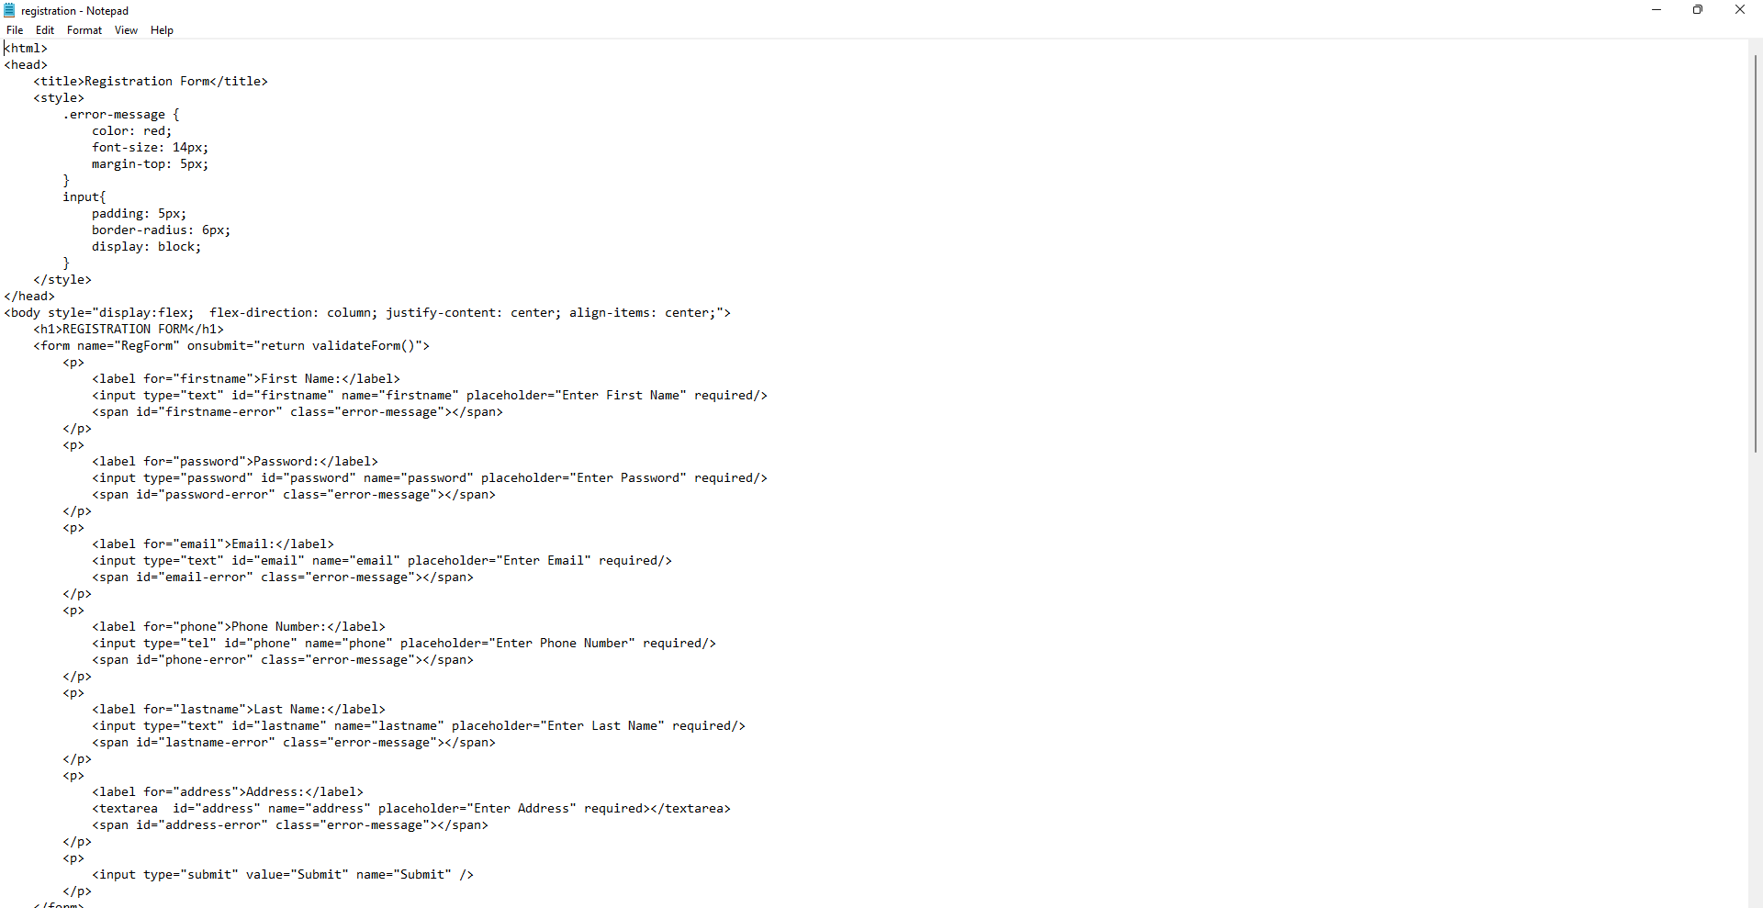
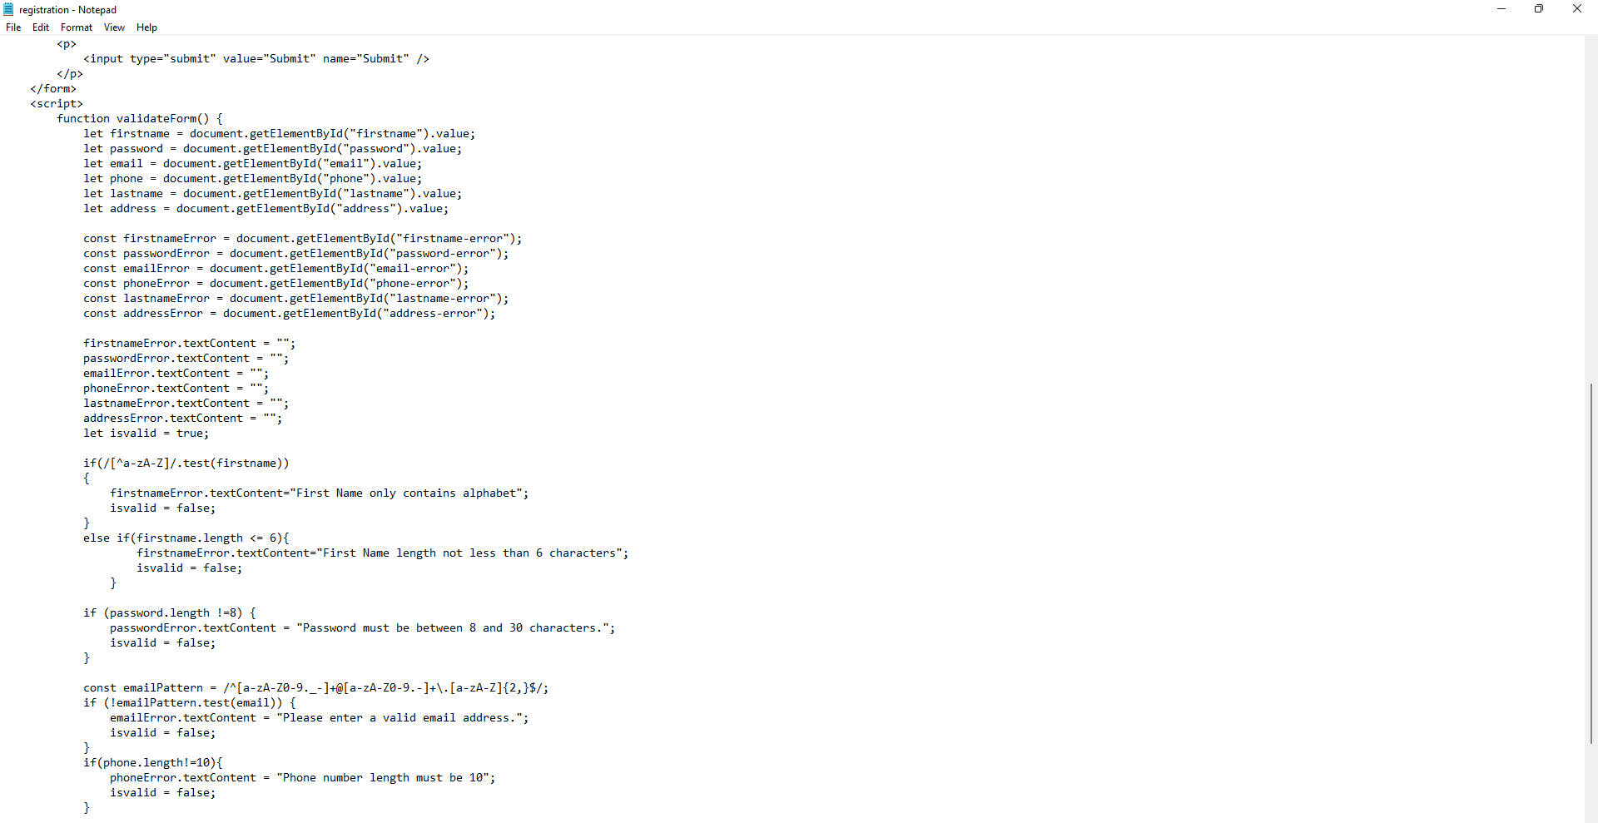

Output:

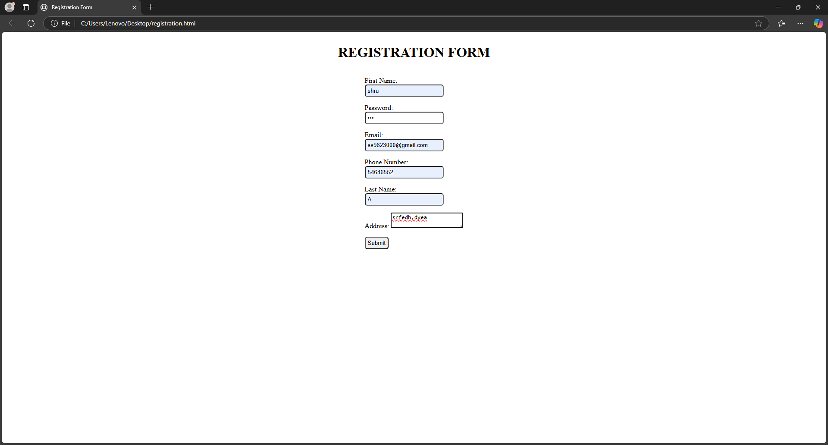

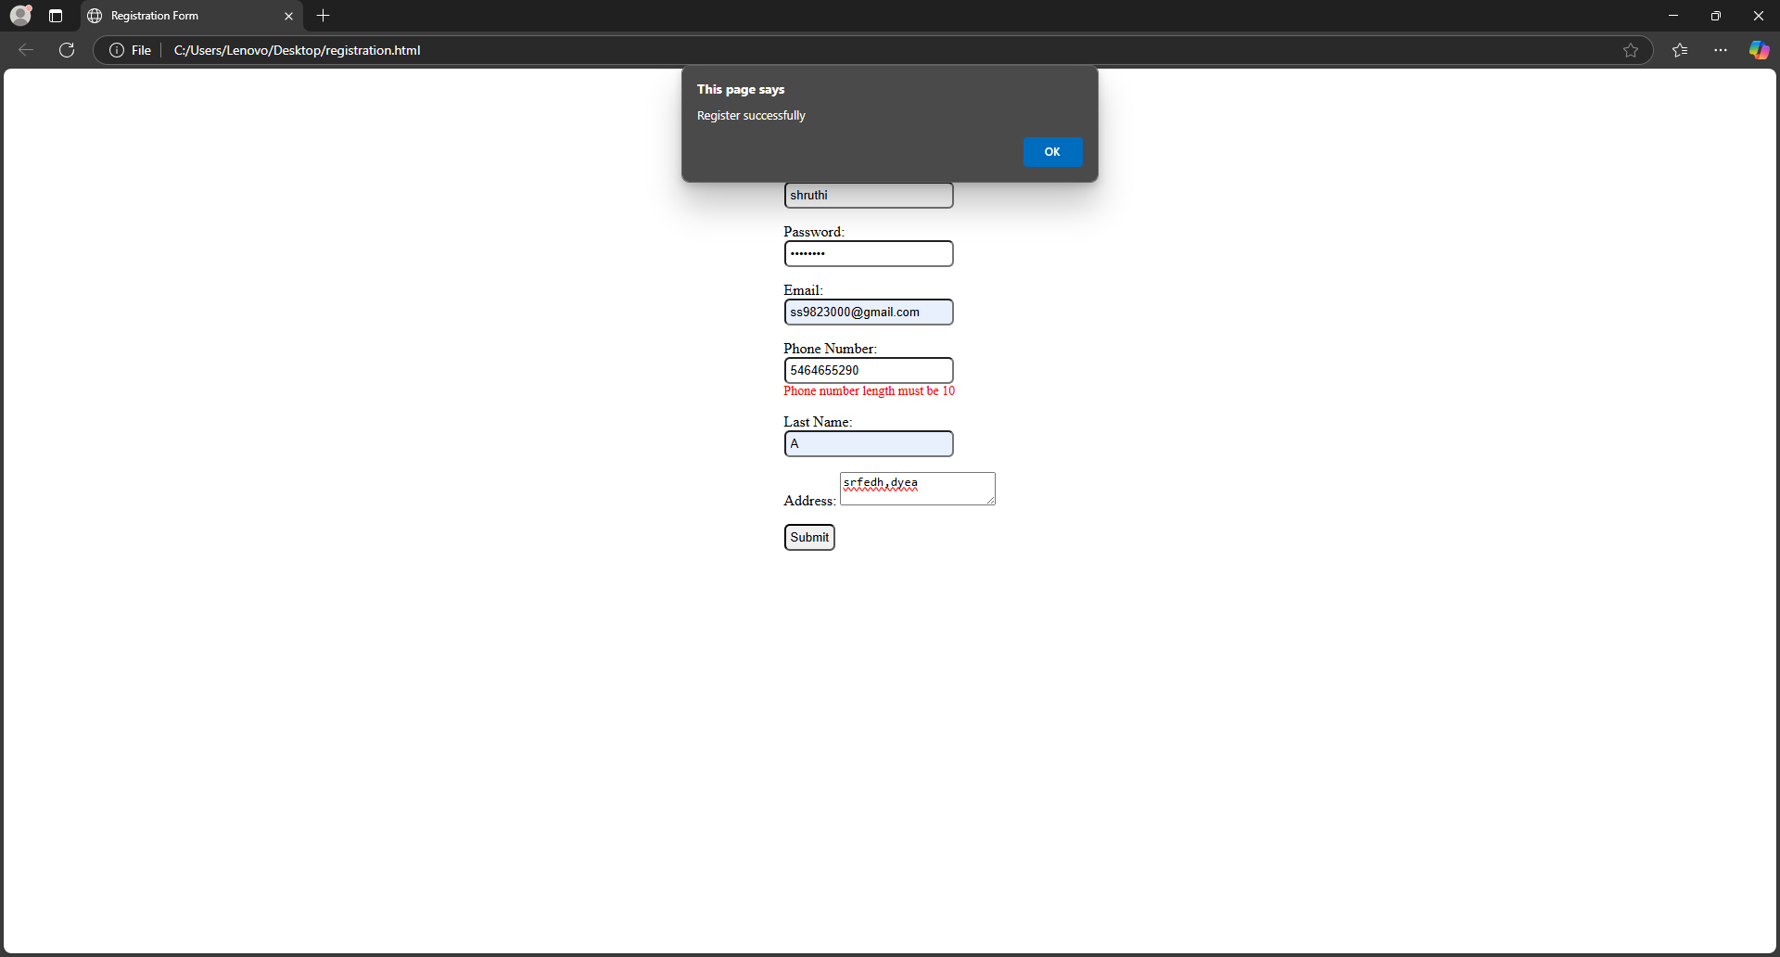

Result:

java script to validate the following fields of the registration page is done successfully.

